ENVIRONMENTAL PROBLEMS
There exist many environmental problems that they are making ill to our planet. These in turn guard narrow relation with other economic and social problems.
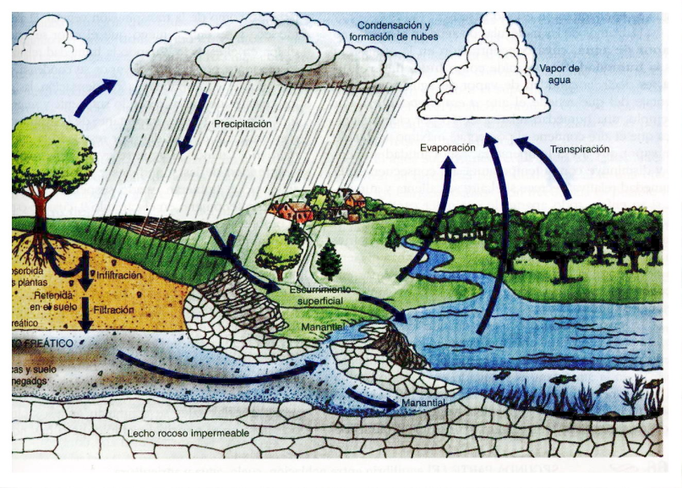
The climatic change:

Greenhouse effect

What is the Greenhouse effect?
The greenhouse effect is a natural phenomenon that has developed our planet to allow that the life should exist and to be called this way precisely because the Earth works as a real greenhouse.

Consequences :

Elevation of the world temperature Melting pole and snow the elevation of the level of the sea between others being the man affected totally by these.
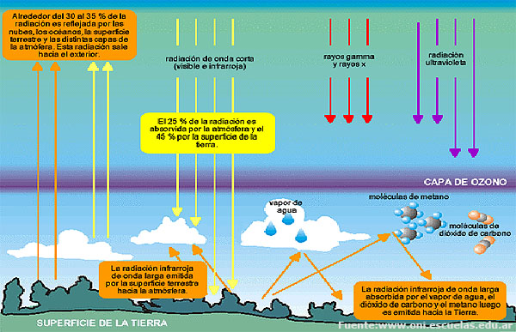
Cap of Ozone
The slimming of the cap of ozone is one of the environmental problems that more is interested to the current world.
It is a question of an area in which the destruction of the stratospheric ozone is very intense for which the protection opposite to the beams UV-B diminishes very much.
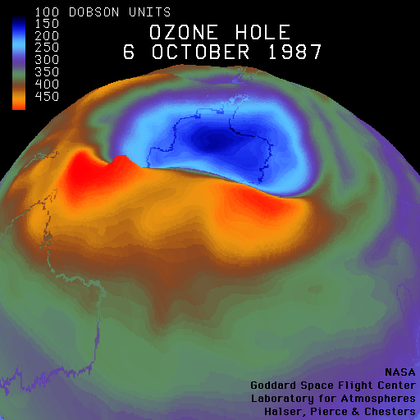
Evolution of the cap of ozone:

Here you can see the evolution of the so called "hole" of ozone, The less ozone is (violet and blue) major it has been the degradation of this important protective cap.
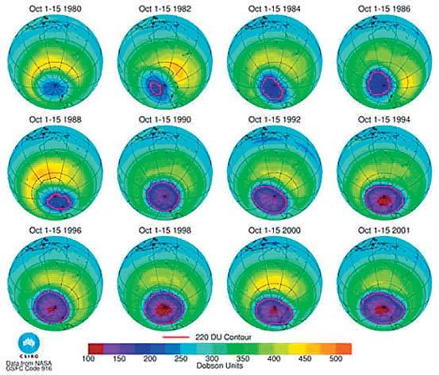
Consequences:

Diseases for the man like cancer of skin produced by the beams ultraviolet since more forts come.
What is the biodiversity?
The biodiversity is defined as the variability of genes, species and present ecosystems in a certain space.
For example, the birds are not all the equal ones but, as well as your you belong different from all the rest boys, between them also there are things that change and that are linked principally to his genes.
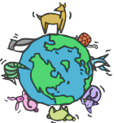
Loss of the biodiversity
The biodiversity is very important for the life in our planet. Many species and ecosystems are disappearing, are going out.

¿How do species become go out?
There are some plants that support very much the cold and there are others that not. There are animals that can live in the depths of the water, as the dolphins, and others that cannot swim even.

What consequences does it bring?
Survival of the life in the planet All the alive(vivacious) organisms need from the others to survive, but also the soil, the water and the air depend on the life of the planet.

ACID RAIN
They are the humid rainfalls (rain, snow, slush, fog and dew) and also to the dry depositions (particles acidificanes and gases) that contain acid components.
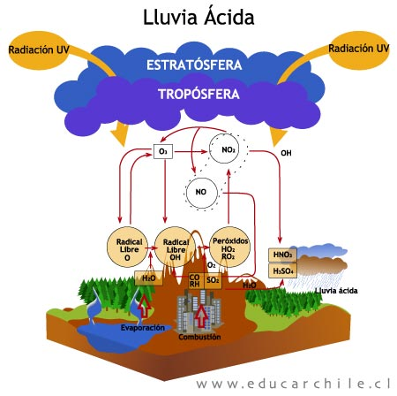
EFFECTS OF THE ACID RAIN.
They can manage to be destroyers, from the acidificación of rivers, lakes and seas that impede the aquatic life, up to the wear and death of the vegetable life in forests.

